If possible, please consolidate orders for your Council/Region to be shipped to one address for multiple locals or sites.

California Labor Federation
NO on the RECALL Materials & Worksite Flier Order Form

Union/CLC | Local
Political Coordinator | Email
Chief Officer | Phone number:

Mailing or shipping address – must be open during regular business hours

City and zip code | Date needed

Specify number needed:

General Public Walk Piece  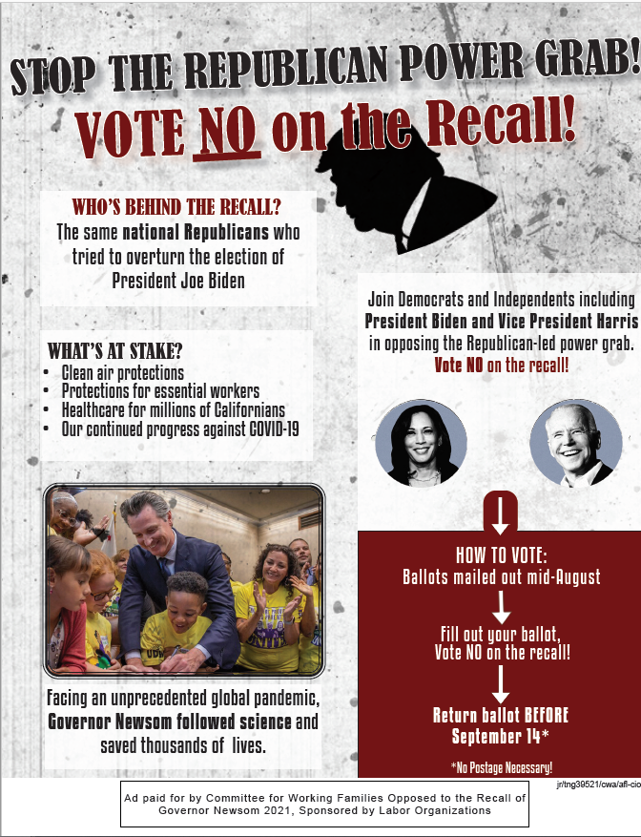  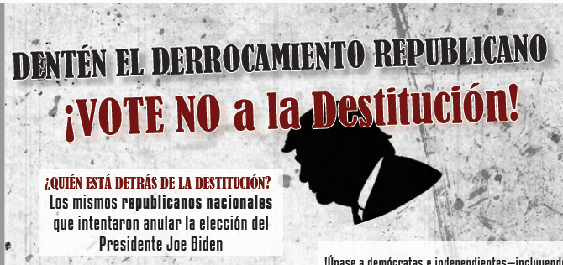  - 6x9  - Bilingual  Quantity: ___________ | Member Flyers  Member-to-Member (6x9):  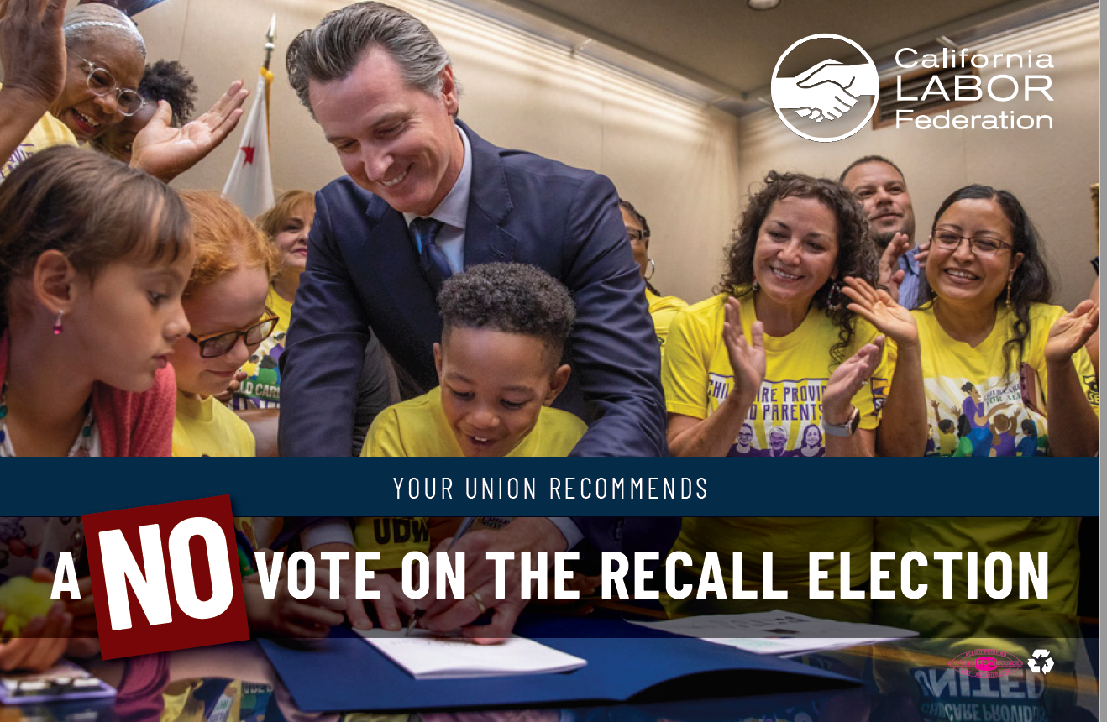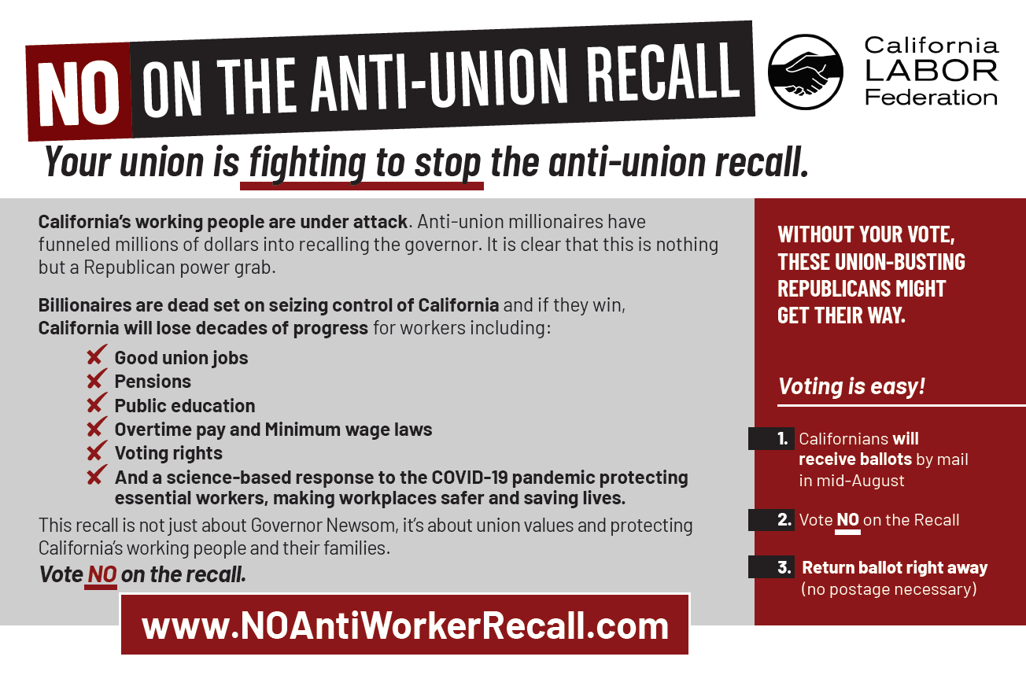  Quantity:  English: ______________  Spanish: ______________  Building Trades (6x9):  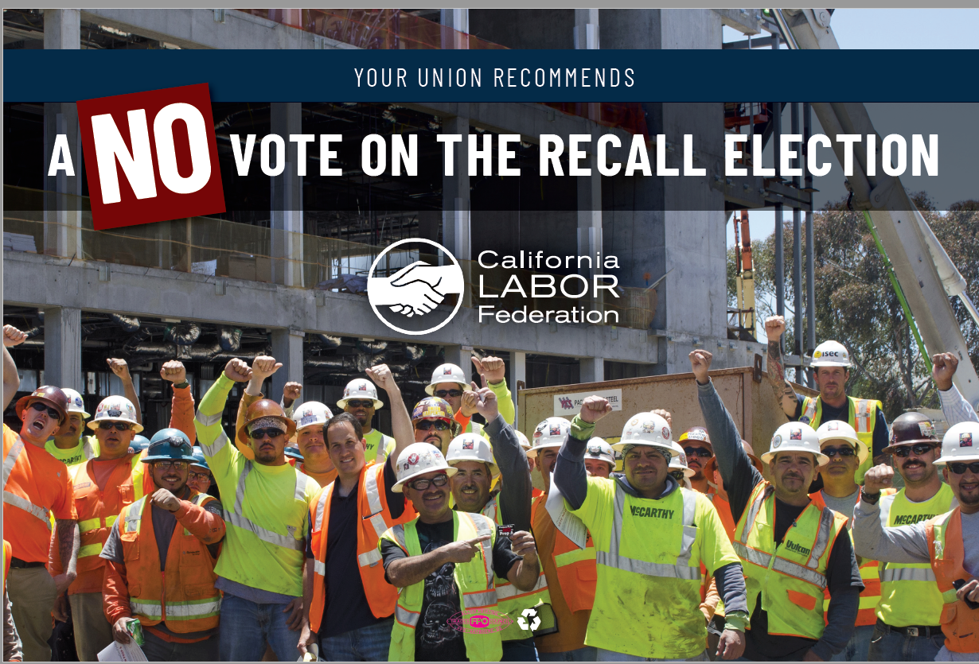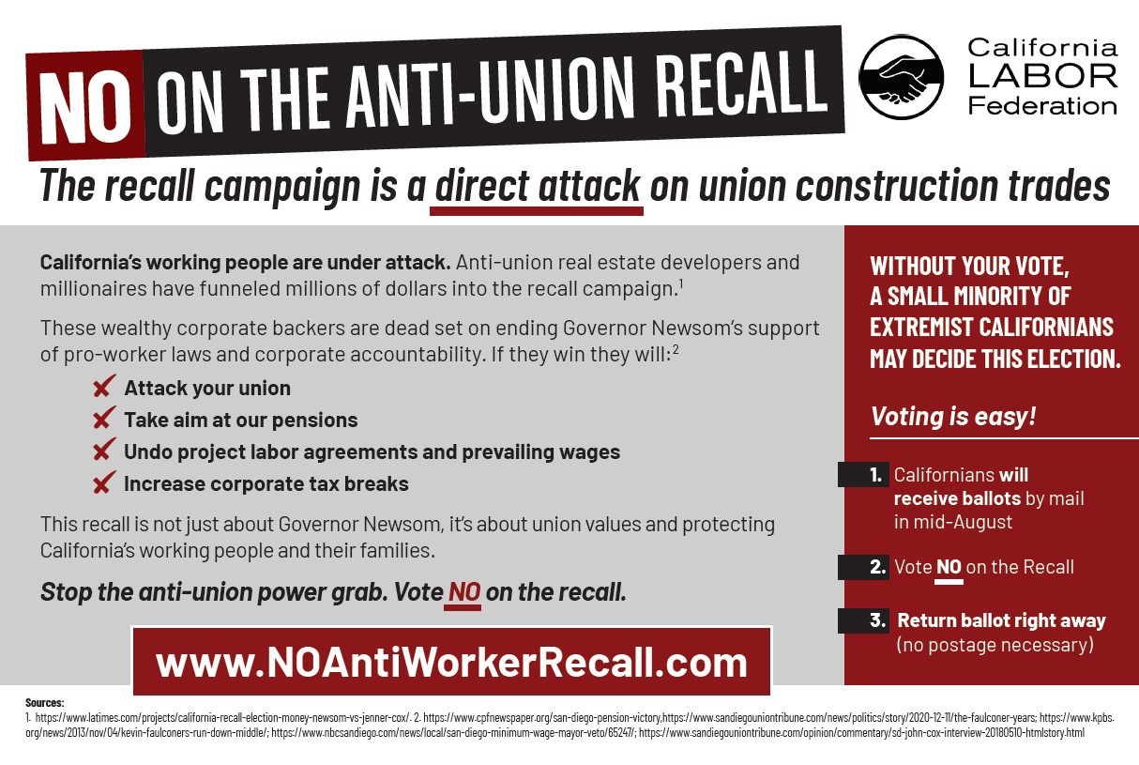  Quantity:  English: ______________  Spanish: ______________ | Pocket Card  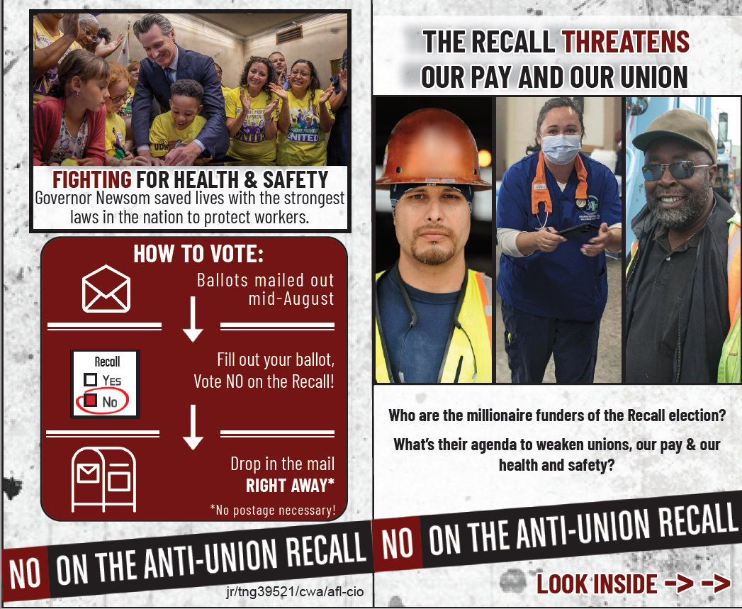  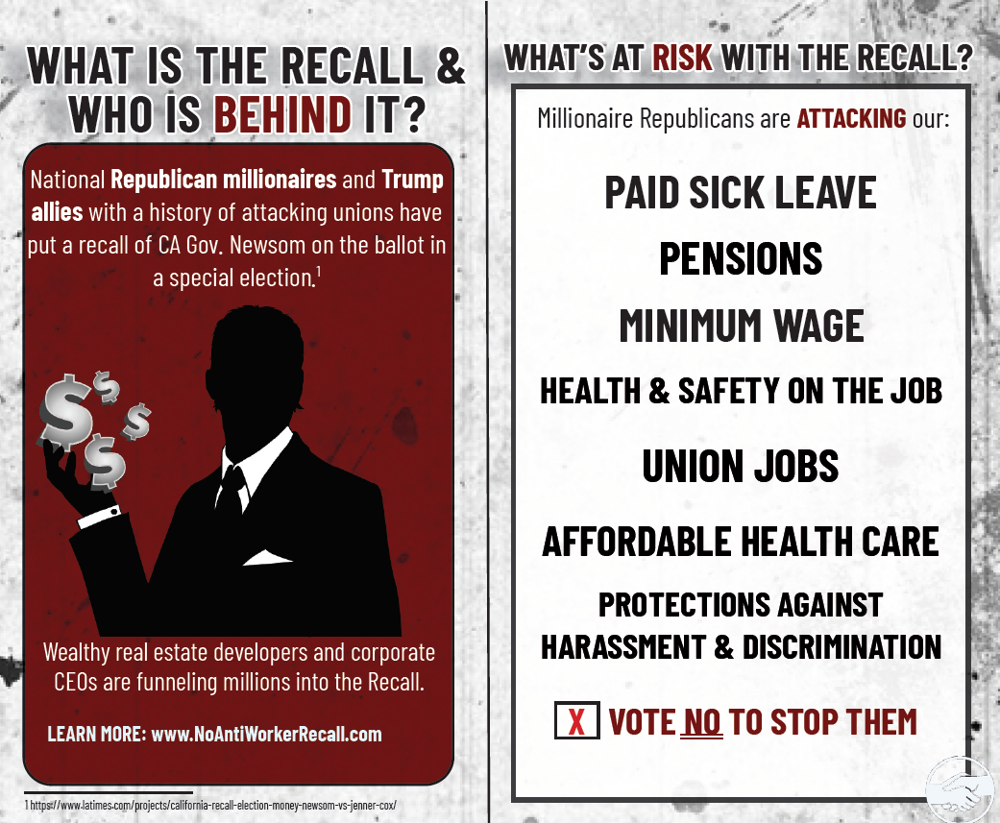  Quantity:  English: ______________  Spanish: ______________  Building Trades Pocket Card  (Same Design)  Quantity:  English: ______________ | Window Sign  (pre-order)  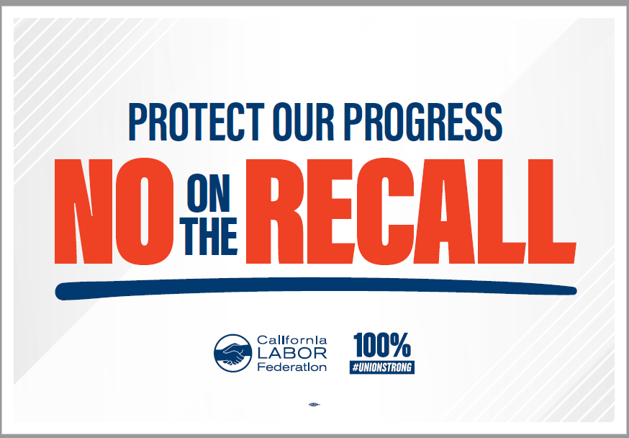  Quantity: ______________  Hard Hat Sticker  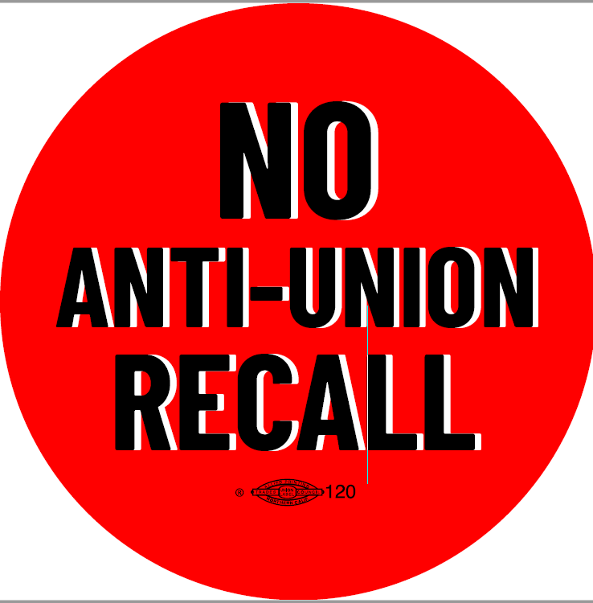  Quantity: ______________

